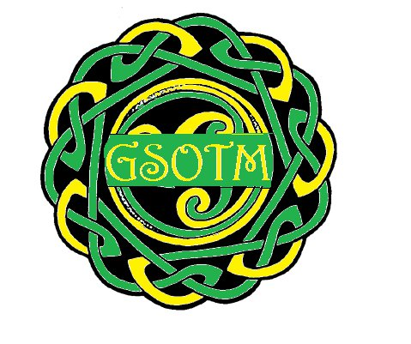
DATA PRIVACY NOTICE

The Committee of the Glengormley School of Traditional Music

1. Your personal data – what is it?
Personal data relates to a living individual who can be identified from that data. Identification can be by the information alone or in conjunction with any other information in the data controller’s possession or likely to come into such possession. The processing of personal data is governed by the General Data Protection Regulation (the “GDPR”).

2. Who are we?
The Committee of the Glengormley School of Traditional Music (GSoTM) is the data controller (contact details below). This means the GSoTM Committee decides how your personal data is processed and for what purposes.

3. How do we process your personal data?
The Committee of GSoTM complies with its obligations under the “GDPR” by keeping personal data up to date; by storing and destroying it securely; by not collecting or retaining excessive amounts of data; by protecting personal data from loss, misuse, unauthorised access and disclosure and by ensuring that appropriate technical measures are in place to protect personal data.

We use your personal data for the following purposes: -
- To administer pupil records;
- To fundraise and promote the interests of the GSoTM;
- To manage our tutors and volunteers;
- To maintain our own accounts and records
- To inform you of GSoTM news, events and activities;

4. What is the legal basis for processing your personal data?
- Explicit consent of the data subject so that we can keep you informed about news, events, and activities.
- Explicit consent of the data subject so that we can take your photograph and use it in GSoTM publications.
- Processing is necessary to allow us to provide the contracted service we have made with you in relation to the provision of musical tuition.

5. Sharing your personal data
Your personal data will be treated as strictly confidential and will only be shared with other members of the committee in order to carry out a specific service or for purposes connected with the GSoTM.

6. How long do we keep your personal data?
We keep your personal data for the duration that you are a pupil at GSoTM.

7. Your rights and your personal data
Unless subject to an exemption under the GDPR, you have the following rights with respect to your personal data: -
- The right to request a copy of your personal data which the Committee of GSoTM, holds about you;
- The right to request that the Committee of GSoTM corrects any personal data if it is found to be inaccurate or out of date;
- The right to request your personal data is erased where it is no longer necessary for the Committee of GSoTM to retain such data;
- The right to withdraw your consent to the processing at any time
- The right, where there is a dispute in relation to the accuracy or processing of your personal data, to request a restriction is placed on further processing;
- The right to lodge a complaint with the Information Commissioners Office.

8. Further processing
If we wish to use your personal data for a new purpose, not covered by this Data Protection Notice, then we will provide you with a new notice explaining this new use prior to commencing the processing and setting out the relevant purposes and processing conditions. Where and whenever necessary, we will seek your prior consent to the new processing.

9. Contact Details

To exercise all relevant rights, queries or complaints please in the first instance contact the GSoTM Chairperson Ray Morgan or Deputy Chairperson Marie Murtagh

